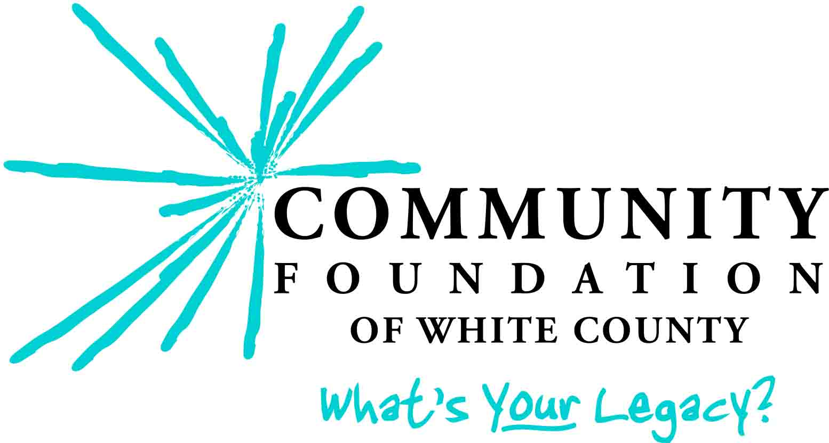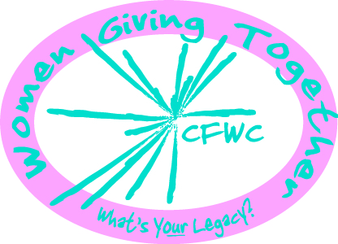

WOMEN GIVING TOGETHER FUND
GRANT GUIDELINES AND PROCEDURES

I. FOUNDATION BACKGROUND
The Community Foundation of White County is dedicated to inspiring people to strengthen White County through charitable giving. The Foundation provides a vehicle for donors, large and small, to make a lasting difference in their community. Gifts are endowed and the earnings are used for the improvement of the social, civic, cultural, economic, and physical environment of White County.

II. WOMEN GIVING TOGETHER BACKGROUND
The purpose of the Women Giving Together Fund of the Community Foundation of White County is to address the hopes and dreams of White County’s women and families, and to inspire women to strengthen White County through charitable giving. Donors to the Foundation’s WGT Fund are engaged in the community and believe that high-priority issues should be addressed thoughtfully to inspire social change and improve the quality of life in White County. As the WGT Fund grows, it is envisioned that the annual grants will increase in size and number.

III. PROGRAM PRIORITIES AND GUIDELINES
- Projects must serve a charitable purpose.

- Priority is given to projects that:
  - Serve the needs of the women and families of the greater White County area.
  - Demonstrate an innovative and unique approach.
  - Indicate funding sources other than the grant requested from CFWC.

- The Focus Areas for Women Giving Together Grants are:
  - ARTS AND CULTURE
  - EDUCATION (K-12 and Continuing)
  - SOCIAL/HUMAN SERVICES
  - YOUTH PROGRAMS

IV. PROJECTS NOT FUNDED
- Non-charitable projects; non-charitable organizations.
- Projects that are normally fully funded by units of local government.
- Projects to fund an endowment, ongoing operating budgets (administrative or personnel costs), existing deficit, debt reduction, or multi-year, long-term funding for projects.
- Religious activities or programs that are serving or appear to serve predominantly one denomination and not the community at large.
- Special events such as parades, festivals and sporting activities.
- Political organizations or campaigns.
- National and State fund raising efforts.
- Projects that indicate discrimination.
The Women Giving Together Fund of the Community Foundation of White County may not be able to fund all grant requests received; however, you are welcome to try again next year!

V. GRANT SELECTION PROCESS
Please review these grant guidelines; they are intended to help you understand what kinds of projects we seek. If you have questions about whether or not your request may fit into our guidelines, please contact Lucy Dold, CFWC Director, at 574-583-6911.

The WGT Fund Grants Committee forwards its recommendations to the Foundation’s Governing Council for final approval. Awards will be announced in early November. Those awarded grants must sign a Grant Agreement; funds will be released upon receipt of expense documentation.

VII. GRANT SUBMISSION DEADLINE: OCTOBER 2
- Applications submitted after the deadline cannot be considered; you are welcome to submit the application next year for consideration.
- Please call the CFWC office to discuss the nature of your grant before submitting a proposal.
- Complete the Application Form (I) and Narrative (II) carefully; fill in all the blanks! Please be kind and type your application using a font size of 11 or larger.
- Please submit seven (7) copies [one signed original (plus six copies for our WGT committee)] of the Grant Application Form and Narrative, including the required attachments. Do not submit information not asked for.
- If you are submitting this proposal under the umbrella of another organization, that organization should complete the organization’s information; please designate a primary contact person.
- Complete proposals must be delivered to CFWC by 5 pm on October 2.
- Grant applications should be submitted to:
Community Foundation of White County
(1001 Airport Rd.)
P.O. Box 1154
Monticello, IN 47960
574-583-6911
lucy@cfwhitecounty.org

The Community Foundation of White County is an Affiliate of The Community Foundation of Greater Lafayette.

