Community Foundation of White County
Mental Wellness Guidelines
&
Application Procedure

Your Community Foundation of White County is committed to strengthening White County through charitable giving and is honored to serve as a vehicle for people who believe that investing in our community is important, relevant, and personal.
In response to county-specific data collected during Lilly Endowment, Inc.’s Leadership Planning Grant under GIFT VII, CFWC identified mental wellness as a focus area for the next five years. This new grant opportunity has been created to make an impact in the mental health space.
Like good physical health, positive mental health promotes success in life. As defined by the Centers for Disease Control and Prevention (CDC), “mental health includes our emotional, psychological, and social well-being. It affects how we think, feel, and act. It also helps determine how we handle stress, relate to others, and make healthy choices. Mental health is important at every stage of life, from childhood and adolescence through adulthood.”
Mental Wellness Grants are made possible by unrestricted donations to the Foundation from everyday people who care about our community. Unrestricted donations allow flexibility for the Governing Council to address ever-emerging community needs.

Who may apply? We support organizations that are classified as tax-exempt under section 501(c)(3) of the Internal Revenue Code.

What is funded? The Foundation is particularly interested in innovative approaches to solving community problems, maximizing unexpected opportunities, and supporting projects that evidence collaboration among agencies. Within the scope of mental wellness, we particularly are interested in projects that:
-expand access to mental health services
-reduce the stigma around mental health
-build protective factors, particularly in youth
-provide evidence-based programs that impact mental wellness
-education or training for parents and youth workers

We look for opportunities that will reach as many people as possible and will improve the ability of the organization to serve the community over the long term. Eligible programs/projects must serve the White County community.

What is not funded? Policies governing the Foundation generally preclude funding for:
Individuals
Endowments
Existing deficits, debt reduction, and multi-year, long-term funding for projects
Religious activities or programs that are serving or appear to serve predominantly one denomination and not the community at large (however, daycare/childcare programs, for example, if open to the public, would be eligible)
Political organizations or candidates
Programs or capital projects already completed.

Please check with the Foundation if you have any questions as to eligibility for funding.

How much funding is available? A total of $50,000 will be available for the 2023 Mental Wellness Grants.

Think creatively!
How will your project enrich and strengthen your community?
Your grant application should be viewed as an opportunity to work with the Community Foundation as a partner involved in your idea (not simply a request for funding).

Submitting your grant application:

- Please call the Foundation before submitting a proposal to explain the nature of your grant, to gain an understanding of the Foundation’s priorities and funding capabilities for the year, and to ensure you have the current application form.

- Complete the Grant Application form provided. All blanks MUST be filled in: if not applicable, please indicate. Your project narrative may not exceed three (3) pages and must address each of the questions listed. Please be certain to include all required attachments with your grant application.

- Please submit an original plus 4 copies of the grant application, including all attachments. Please do not staple or otherwise bind or package the application.

- Please include only the information requested. Any additional material will not be provided to the Community Grants Committee.

- The proposal should be submitted by a charitable organization. If you are submitting this proposal under the umbrella of another organization, that entity should complete the organization’s information. Please designate a primary contact person with his/her address and phone number.

- Your request will be assigned to a Community Grants Committee member. You may be contacted for further information or to schedule a site visit.

- Complete proposals must be IN the Community Foundation office by 5:00pm Monday, October 2nd, 2023. Recommendations will be approved first by CFWC Governing Council, and then the Community Foundation of Greater Lafayette Board. Awards will be announced in late November.

- Please return to:

Community Foundation of White County
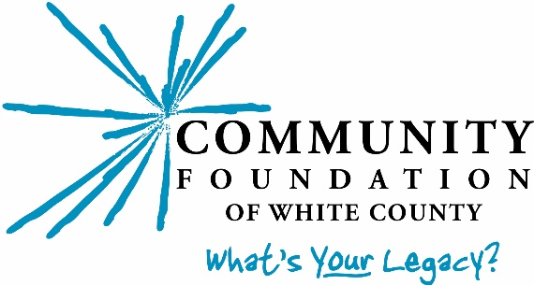
(1001 Airport Rd.)
P.O. Box 1154
Monticello, IN 47960-1154
(574) 583-6911
www.cfwhitecounty.org

