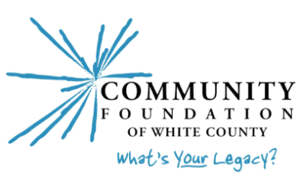
Community Foundation of White County
Community Cares Grant
Guidelines & Application Procedure

Your Community Foundation of White County is committed to strengthening White County through charitable giving and is honored to serve as a vehicle for people who believe that investing in our community is important, relevant, and personal.
Our Community Cares Grants are made possible by unrestricted donations to the Foundation from everyday people who care about our community. Whether large or small, these “use where they will best serve” gifts allow the Foundation’s Governing Council to offer grant opportunities to strengthen the social, cultural, educational, economic, and physical well-being of White County.

Who may apply? To be eligible, your organization must have non-profit, 501c3 status. This includes units of governments, school corporations, and religious organizations.

What is funded? The Foundation is particularly interested in innovative approaches to solving community problems, maximizing unexpected opportunities, and supporting projects that evidence collaboration among agencies. Examples include:
- Start-up costs for a new or expanded project (should indicate plan for future support and sustainability)
- One-time projects that address a critical need
- Capital improvement projects that are beyond an applicant’s means
- Projects for which support from CFWC will enable applicants to obtain matching funding from other sources.
We look for opportunities that will reach as many people as possible and will improve the ability of the organization to serve the community over the long term. Eligible programs/projects must serve the White County community.

What is not funded? Policies governing the Foundation generally preclude funding for:
Individuals
Endowments
Ongoing operating budgets, existing deficits, debt reduction
Religious activities or programs that are serving or appear to serve predominantly one denomination and not the community at large (however, daycare/childcare programs, for example, if open to the public, would be eligible)
Political organizations or candidates
Programs or capital projects already completed.

Please check with the Foundation if you have any questions as to eligibility for funding.

How much funding is available? A total of $45,000 has been allocated for Round One 2024 Community Grants to eligible nonprofits serving White County.

Think creatively!
How will your project enrich and strengthen your community?

Submitting your grant application:

- Please call the Foundation before submitting a proposal to explain the nature of your grant, to gain an understanding of the Foundation’s priorities and funding capabilities for the year, and to ensure you have the current applications form.

- Complete the Grant Application form provided. All blanks MUST be filled in: if not applicable, please indicate. Your project narrative may not exceed three (3) pages and must address each of the questions listed.

- Please submit an original copy of the grant application, including all attachments.

- The proposal should be submitted by a charitable organization. If you are submitting this proposal under the umbrella of another organization, that entity should complete the organization’s information. Please designate a primary contact person with their address and phone number.

- Your request will be assigned to a Community Grants Committee member. You may be contacted for further information or to schedule a site visit.

- Complete proposals must be IN the Community Foundation office by 5:00pm, Friday, April 5th.

- Timeline:
April 5th Due date for Community Cares Grant Application
May 1st Recommendations presented to CFWC Council for approval
May 30th Final approval with CF of Greater Lafayette Board
Early June Grant awards announced/funding available (pending grant agreement)

- Grant Disbursements and Evaluations: Before grant funding is available, the grantee and the Community Foundation will execute a grant agreement. Generally, grants are distributed on a reimbursement basis. The program staff may visit the grant site to check in on progress or experience the project in action.
- Please return to:

Community Foundation of White County
(1001 Airport Rd.)
P.O. Box 1154
Monticello, IN 47960-1154
(574) 583-6911
www.cfwhitecounty.org
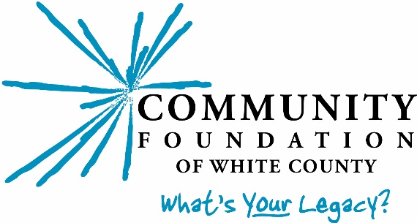
lucy@cfwhitecounty.org

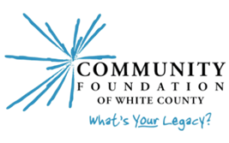
Community Foundation of White County
Community Grants Application 2024
Round 1 (deadline: 5:00 pm, April 5)

ORGANIZATION

Organization’s Legal Name

Street & Mailing Address

City, State, Zip

Phone Fax E-Mail

President/CEO

Contact Person (if different from above) Phone

Federal ID#

Organization’s Mission Statement:

PROJECT INFORMATION

Project Name/Activity

$ $
Amount Requested Total Project Cost

Project Timeline (start and completion dates)

SIGNATURE AUTHORIZATION

President/CEO Date
CFWC Grant Application
Page 2

Grant Application Narrative
Please address the following questions with brief, concise, and specific responses, and attach to the Grant Application Form. Narrative should be no more than 2 pages; may not exceed 3 pages.

1. Organization: Describe your organization’s primary purpose and history.

2. Project Description: Please describe the nature and purpose of the project.

3. Need/Opportunity: What community need/opportunity does this project address?

4. Impact: Describe the effect of this project on your organization, staff, clients, & community. How many people will benefit? What geographical area will be served?

5. Coordination: Is your organization collaborating with other organizations around this issue/project? List all organizations and key persons that will be responsible for this project.

6. Timeline: Please include a project timeline detailing anticipated start and completion dates.

7. Funding sources: Please list other contributors to this project; include organization’s name, amount, and status of the other donations. Be sure to include your organization’s commitment.

8. Sustainability: How will this project be financed in the future? If only partially funded by CFWC, will the project still occur? Please explain.

9. Publicity: If funded, how will CFWC’s support be publicized in your circles?

Required Attachments:
  - Detailed Project Budget (see attached form) – You may reproduce the form on your computer, provided the format is closely followed.
  - Financials (Summary Forms) – We do not want every detail of your entire budget. Please include financials relevant to the identified project only, not the town’s entire financial report, e.g., a parks department project request is not related to personnel expenses, the water department, etc.]
  - IRS Determination Letter – include a current IRS determination letter showing exemption from federal income taxes under Section 509(a) of the IRS Code and your 501(c)(3) status.
  - Board Members – include a list of your current Board members, their occupations, and addresses.

Please submit a signed original to:
Community Foundation of White County
(1001 Airport Rd.)
P.O. Box 1154
Monticello, IN 47960-1154
(574) 583-6911
lucy@cfwhitecounty.org
For CFWC Use ONLY:

Date Received Proposal #
Category/Field of Interest
Date_______________ Approved_____ Declined_____ Amount Awarded $
Conditions s

Project Budget Form

Revenue to support project:
Source | Amount Pending | Amount Committed

Total

Expenses for total project: Please attach bids or estimates for ALL items.
Item | Total amount  needed | Portion requested from CFWC

Total

